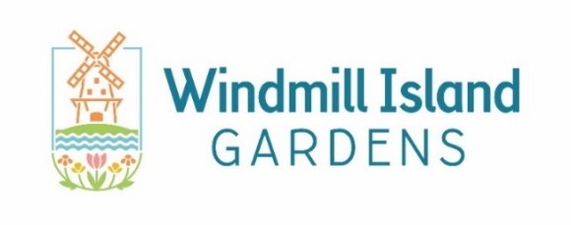

FOR IMMEDIATE RELEASE
September 23, 2024

Busy Windmill Island Gardens Extends Season into October

Holland, MI – For just the fourth time in history, Windmill Island Gardens welcomed over 130,000 guests. Due to visitor demand, the park will remain open on weekends into mid-October and bring back special events this fall and winter.

According to the General Manager Matt Helmus, the Island’s four busiest seasons ever have been 2024 and the past three years. “We are blown away by the amount of people choosing Holland as a vacation destination, many of whom make the trek to visit us,” states Helmus. While it appears 2024 will end up just shy of the all-time record set in 2023, he believes that “If it weren’t for tulips deciding to only bloom for the first half of Tulip Time, we’d have a new record.”

While Holland has long been a premier destination for Midwesterners, the area is seeing an increase in guests from around the country and world. David Blauw, a greeter at Windmill Island Gardens, makes a practice of noting the countries of the park’s international guests. Since April, his list includes visitors from 95 nations. “Luxembourg, check. Yemen, check. Guinea-Bissau, check. Czech Republic, check. Plus ninety-one other countries. It’s a joy to host them,” reports Blauw.

This year, many of the park’s visitors chose to visit post-Tulip Time and were treated to a wide variety of annuals and perennials in the 36-acre park. General Manager Helmus notes that each month with the exception of May has seen larger crowds than last year. “People are getting the message that summer and fall are great times with nicer weather and no massive crowds like Tulip Time.”

More crowds are expected toward the end of the season as Windmill Island Gardens will once again host an Artisan Market as part of Downtown Holland’s Fall Fest. Guests on October 4 and 5 can visit 85 local vendors selling a wide variety of arts and crafts. Admission for the event is $5 with more details including hours at hollandfallfest.com.

After Fall Fest, the park will re-open for weekends (Friday to Sunday) through October 20 at a reduced admission of $5. Guests may catch sight of the park’s staff planting over 168,000 tulip bulbs for next spring’s festival.

After closing out the regular season, the park will remain busy through the end of the year. The popular Magic at the Mill holiday event returns for weekends in December. Staff expects to see similar crowds to last year’s sell-outs when over 10,000 guests enjoyed a ‘tulip field’ of 1,000 LED blossoms displaying a light and music show along with visits from Sinterklaas, holiday music on the Amsterdam Street organ, Dutch-style holiday food, kid’s activities and plenty of photo opportunities. Public ticket sales begin November 1 at magic.windmillisland.com.

More information on these events and more can be found at windmillisland.com.

###

Contact: Matt Helmus, Windmill Island Gardens General Manager
m.helmus@cityofholland.com, 616.355.1030

About Windmill Island Gardens: Windmill Island Gardens offers a small slice of the Netherlands in West Michigan. The park features tours of ‘de Zwaan’ – America’s only authentic, working Dutch windmill. Other highlights include an Amsterdam street organ and children’s carousel among many Dutch replica buildings and exhibits. During Tulip Time in May, visitors can delight in 150,000+ tulips in beds and fields. A proud member of the American Public Garden Association and American Horticultural Society, the Island is transformed each summer with a beautiful display of annuals and perennials found in themed beds and throughout the landscape. Visitors can enjoy it all from mid-April to early October each year.

